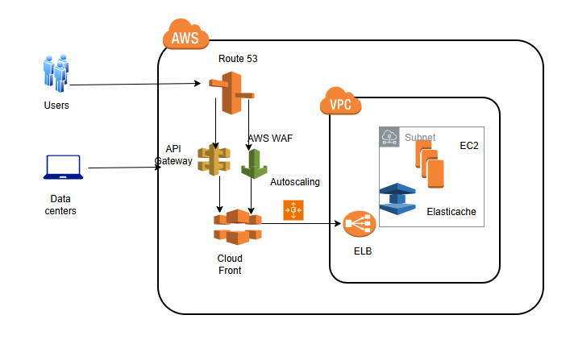
- Route 53-to resolve DNS & any provision related to routing services
- AWS WAF- To define custom rules to block offending traffic based on IP, headers, and patterns.
- API gateway- To manage direct API requests to AWS Lambda, EC2, DynamoDB, or other backend services.
- CloudFront- To act as a CDN (Content Delivery Network) to cache content closer to customer locations, reducing origin traffic and mitigating attack impact.
- Elastic load balancer- To distribute incoming traffic across multiple EC2 instances in different Availability Zones, preventing a single point of failure.
- Elasticache- To manage caching service & improve application
- Auto Scaling – Ensures the system scales up/down to handle traffic spikes during an attack.

